The New Abstract – An Atlantic Bridge – USA – BERLIN

Jonni Cheatwood, Taylor A. White, Robert Szot, Alan Neider
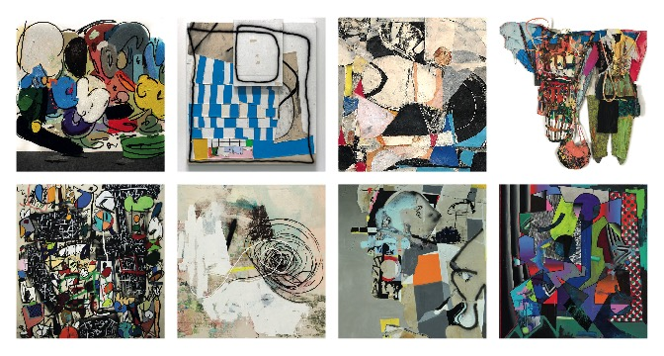
Taher Jaoui, Jenny Brosinski, Gregor Hiltner, Christian Achenbach

We cordially invite you to the opening of the exhibition on the 03.05.2019 at 7 pm

Who would have guessed that social media built portable bridges? Thanks to Instagram the artist and curator Gregor Hiltner discovered a variety of new American abstract painters who, with refreshing creative freedom in technique and composition, continue the great tradition of abstract American painting by giving them – each in their own way – an individual twist. This group of American painters corresponds to a number of Berlin-based painters who follow similar paths. It is not surprising that these artists all feel at home with social media and that, therefore, they know and appreciate one another. Their common ground, to be found both in tradition and in the shared experience of a globalized world with international markets, serves as base from which these artists have set off in different directions.
Their artistic navigation instruments are complex and feed on different roots. For example, the work of Los Angeles-based artist Jonni Cheatwood has a lot to do with the tension between belonging and alienation both rooted in his biography. He combines old, nostalgic prints, with wildly applied colorful shapes and gestures. A nuance of nostalgia is also present in the images of New York artist Robert Szot, whose collages are classics in a new outfit. The strong dynamic of the images of Berlin-based French artist Taher Jaoui, in turn, arises from the contrast between strict scientific, mathematical formal language and childlike, intuitive colors and shapes. The vocabulary of pictorial language in the works of Richmond-based artist Taylor A. White and Berlin-based artist Gregor Hiltner, on the other hand, rarely point to anything outside themselves. Yet,when they refer to something else, it is often done to depict the absurd. Their artwork is usually uncompromising and hermetic, and the poetry of the composition feeds on the contradiction of its elements in both color and form. Equally radical in its own way yet with very fine nuances, Berlin artist Jenny Brosinski creates her often minimalistic compositions, in which even the basic material, the canvas, speaks to the observer.

Finally, we find a decidedly poetic treatment of special materials by the New York artist Alan Neider, who, in his "Bag Paintings", brings to life the most diverse fabrics and accessories eternally liberated from their contexts in his painted fabrics and assemblages. What connects all of these artists is a cheeky collage technique, also used by the Berlin artist Christian Achenbach in his colorful and multi-layered spatial nestings.

We are looking forward to this encounter in the real world to which you are cordially invited!

Marie Christine Kremers

Duration of the exhibition: 03.05.19 - 14.07.19

