Taher Jaoui – Opening Dimensions
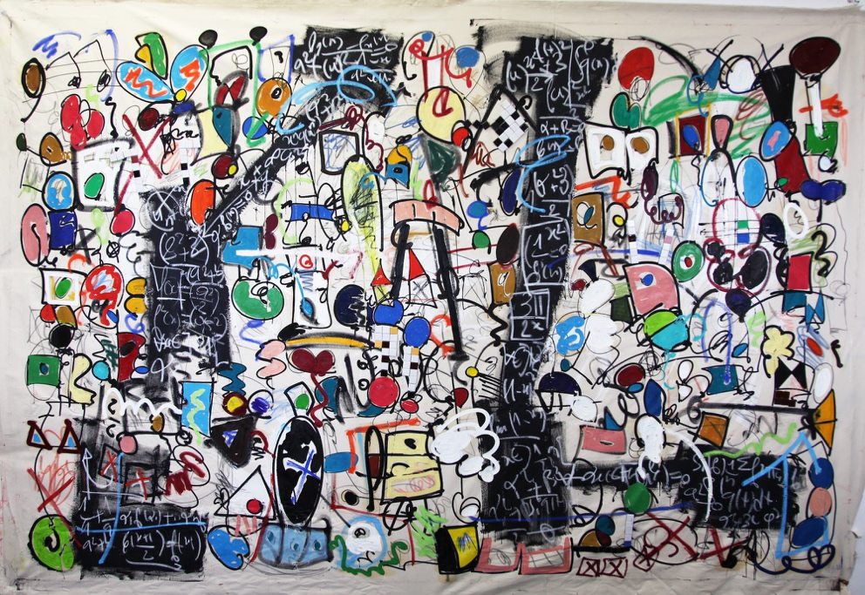
Taher Jaoui, It´s your own perception, 2019, 200 x 300 cm

Invitation to the opening of the exhibition on the 07.09.19 at 7 pm

“It's your own perception". The title invites spectators of Taher Jaoui´s paintings to follow the free play and dance of elementary particles on the canvas, which separate and connect in almost infinitely different formations according to colorful scores. Taher Jaoui’s cosmos is always in motion. (Auto)-poetically, Taher´s elements unite to conglomerates, disconnect in colourful explosions, or form rhythmic series.

Just like in his paintings, numbers, signs, and letters on the chalk boards of the mathematician Taher Jaoui are dancing. The French artist with Tunisian roots who lives and works in Berlin studied financial mathematics. He was familiarized with the aesthetics of the world of mathematical formulas and symbols by his mother, a math teacher, when he was still a child. Thus, the aesthetic and the mathematical dimension are combined in an 8 x 2.20 m painting exclusively produced for the gallery space, in which Taher Jaoui inscribes the series of the mathematician Brook Taylor in a composition of informal painting.

In addition to canvas paintings in various formats, this exhibition shows an installation where the movement on the canvas seems to affect the material itself and thus breaks the limits of the stretched rectangular canvas, which finally leads to his step into the third dimension by way of a series of abstract sculptures.

A good part of the exhibition was produced in the gallery and the artwork reflects the architecture of the space. This process was documented in a video, which will be shown in and during the exhibition. We can watch the artist at work. In this very personal respect, too, Taher Jaoui opens dimensions and shows something he has not yet shown before in any of his numerous solo exhibitions in Europe, Africa, Asia, and the USA.

Special opening hours during Berlin Art Week:
Thu, 12.9. and Fri, 13.9., 11 am 8 pm, Sat, 14.9., 11 am to 8 pm and Sun, 15.9., 11 am to 6 pm.
Duration of the exhibition: 08.09. - 02.11.2019

