GALERIE KREMERS
Schmiedehof 17 (Eingang Eberhard-Roters-Platz) 10965 Berlin
Öffnungszeiten: Mo – Fr, 11 h – 18 h und nach Vereinbarung
T. +49 30 469 98 068 /+49 176 647 27 247 - www.galerie-kremers.com - info@galerie-kremers.
GALERIE KREMERS is happy to invite you to the opening of the exhibition
Fiona Ackerman – Metamorphosis II – The cosmic tiger
Opening 29.4. 21 from 6 – 9 pm | 30.4.21 from 11 am – 9 pm | 01.5. – 2.05.21 from 12 - 9 pm, Gothic Hall

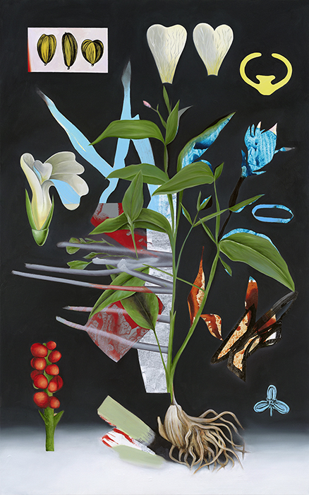
“There is nothing in the caterpillar, that tells you it's going to be a butterfly." (Buckminster Fuller)
In a transformation, only the external changes are visible. We may not even realize that we are in a process of change, but consider the small visible part to be the whole. “Under Garden” shows the limitations of our perspective in a paradoxical way: beauty blooms from the invisible, offering an overall view of metamorphosis, as though perceived in all its stages simultaneously, even the hidden ones.
Fiona Ackerman plays with the possibilities and limits of human perception and asks what metamorphosis means to the subject of change. Can I influence the transformation I am undergoing? Who am I when the transformation process is complete?
See for yourself and let yourself be transformed ...!
Fiona Ackerman, Under Garden, 2019, 163 x 102 cm
In her third solo exhibition at GALERIE KREMERS, Fiona Ackerman presents a series of images made during the COVID-19 lockdown exploring Metamorphosis. A series of new paintings explore three thematic areas: the zoological works of the 17th century researcher and artist Sibylla Maria Merian treating the metamorphosis of butterflies; Schrödinger's Cat, a 1935 thought experiment proposed by physicist Erwin Schrödinger; and the overnight transformation of an office worker into a bug in Franz Kafka's 1915 novella The Metamorphosis.
A highlight of the exhibition is a video by Fiona Ackerman and New York musician and video artist Arjan Miranda. Elements of the painter’s compositions are transformed into moving images by Miranda; she in turn creates visual responses to his compositions. The music for the video, I Am Strange on the Inside, is the artists' collaborative exploration.
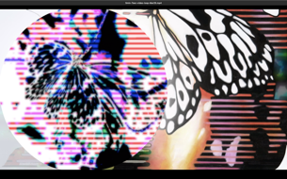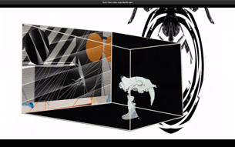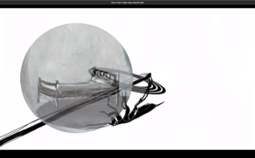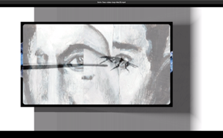
Video Stills by Fiona Ackerman, Video by Arjan Miranda and Fiona Ackerman

Accompanying exhibition catalogue published by Edition Kremers. Exhibition dates: 04/29 - 07/03/21. With thanks to Stiftung Kunstfonds / Neustart Kultur

