GALERIE KREMERS
Schmiedehof 17 (Eingang Eberhard-Roters-Platz) 10965 Berlin
Öffnungszeiten: Mo – Fr, 11 h – 18 h und nach Vereinbarung
T. +49 30 469 98 068 /+49 176 647 27 247 - www.galerie-kremers.com - info@galerie-kremers.
GALERIE KREMERS is happy to invite you to the opening of the exhibition
Erik Nieminen - Metamorphosis I – Possible Worlds
Opening 29.4. 21 from 18 – 21 pm | 30.4.21 from 11 – 19 h | 01.5. – 2.05.21 from 12 - 20 h

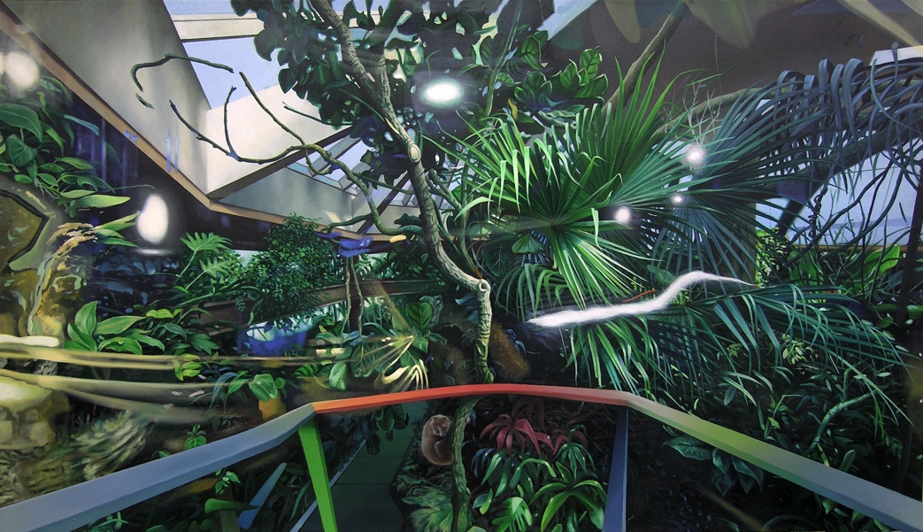
Paradise Not Lost, 2020, Oil on Linen, 95 x 165 cm
Paradises exist. There are artificially created places, for example zoos or gardens, which remind Homo Sapiens of where he actually came from. Erik Nieminen's painting practice is an exploration of possible space. It shows us the manifold worlds open to us when we withdraw from the gravity of the real (everyday) world and reflect on what has always shaped our perception and our experience: a mélange of sensory impressions, often reflected by memories, moods, hidden longings and premonitions, such as of the epochs when our ancestors still lived in the trees. Metamorphoses takes place on the canvas. Erik Nieminen deconstructs fragments of reality, geometric shapes, memory snippets and random findings in order to abet the construction of new worlds. Like in an alchemical process, forms and figures find and lose their role in the resulting composition until the metamorphosis is complete. Here the possible becomes real and vice versa. Since we are all made of the same matter, we can discover related and familiar ideas, concepts, and meanings. Erik Nieminen's paintings speak to us and invite us. They are portals to another world in which we can connect with what we find on the canvas and within our imaginations, the most creative and freest parts of ourselves.

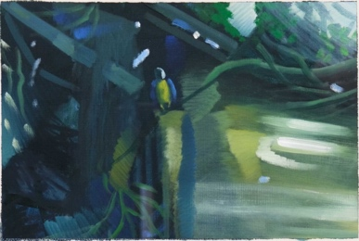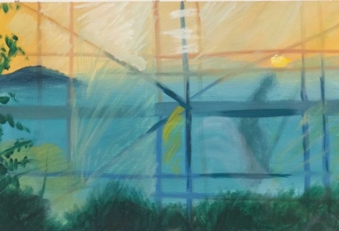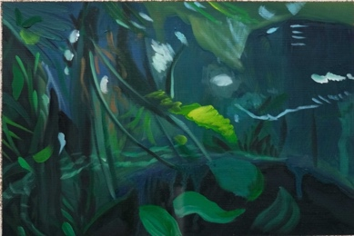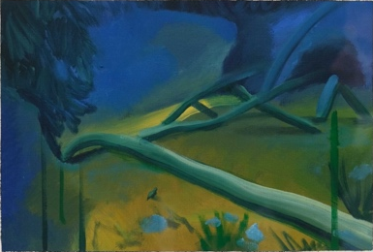
Studien zu „Paradise not Lost“ u.a., 2016-2020, Watercolor on paper, 30,5 x 40,5 cm

Exhibition Dates: 29.04. – 03.07.21 – The exhibition is accompanied by a catalog.
We thank the „Stiftung Kunstfonds., NEUSTART KULTUR“.

